Nostalgia - How About a Nice Cup Of Tea!
There can be nothing more soothing for many people than a nice cup of tea, whether with milk and sugar or simply a slice of lemon. Either way, it relaxes the mind and allows time to wind down from the hectic schedule of daily life, providing nothing less than peace and tranquillity for all. These special moments, with a cup of tea in hand, allow us to reflect on the past and review our future in a far more effective way than any business meeting.
Ipoh Laies Serve Tea to Penang Refugees
Ipoh Railway Statuin 1942
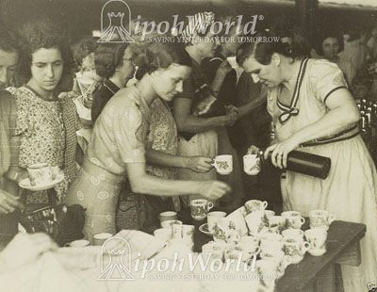
Historically though, the art of taking tea has changed dramatically over the centuries.
Although there are popular legends from both China and India about who discovered tea, it is likely that it grew out of the habit of people chewing tea leaves for medicinal purposes about 2000 years ago. Tea has remained popular ever since.
Let us think back a moment to your first cup of tea. Did you remember that the tea leaves came loose in a nicely decorated tin that could be displayed on the sideboard? We called it a ‘Tea Caddy’. In those days there was a special formula for the quantity needed to make a successful brew: “A teaspoonful for each and one for the Pot.” Boiling hot water and a period of infusion was then required to ensure exactly the perfect taste.
In those heady days, there were different varieties of teas for special occasions. The day would start with English Breakfast Tea and for sure there would be Earl Grey around 4pm, with sandwiches and cakes. Then there would have been a nightly ‘cuppa’ before bedtime. Here personal choice would take over as a drink before bedtime can either soothe or disturb one’s sleep if the wrong choice is made.
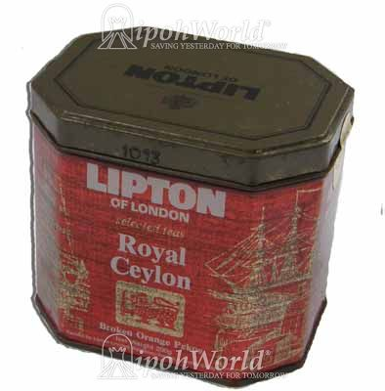
Then came those ghastly things called Tea Bags. Said to be nothing less than the sweepings from the factory floor, they were greeted with confusion and dislike by those who only knew loose tea. Patented in 1904 tea bags did not become generally popular until the 1960s. Once these dreadful things became a growing trend, several famous companies like Lipton, Tetley and Lyons, were quick off the mark to adopt the new product. English children soon coined a phrase for these monstrosities, “Tetley’s tiny tea bags, full of Tetley’s tatty tea”. Nonetheless, those horrible little bags caught the imagination of the world and today it is common practice to serve your guests a mug of tea complete with bag, string and tag adorning the offering. Whatever happened to grace and style?
A Tin of Lipton’s Loose Tea c1980
Recently manufacturers have come up with a new, round tea bag known as Fresh Brew bags. The removal of the string and label is definitely a step forward but it does not improve the feeling of something ghastly lurking in the bottom of your cup.
An article about traditional tea cannot be complete without a mention of Malaysia’s own Boh Tea, said to be our most popular brand since 1929. They produce a wide range of quality teas, both loose and in tea bags, but let me assure you, the latter are not sweepings off the floor.
So let us sit back and relax with a nice cup of tea. It is the perfect time for nostalgia, itself a powerful emotion. Allow yourself a few minutes to enjoy the past and reflect on the future. You will not regret the time spent.

